Course: ITD 2343 OOP Using C# Grade **_______**

Instructor: Mark Pranger

Student Name: Cristhian Carcamo

Due Date: 1/12/2025

Gradebook Comments: Copy the Gradebook comments and paste them here

## Week 1 - Programming Lab

## 

**In Explorer, find the folder containing the project you just created. Then do the following screen shots of the various folders and contents.**

* **Show the folder containing the Solution file (include showing the solution file in the screen shot)**
* **Show the folder containing the Project files (include the files and other subfolders in the screen shot)**
* **Show the contents of each of the subfolders (only go one level down, if there are subsubfolders just make sure those folders names show up in the screen shot)**

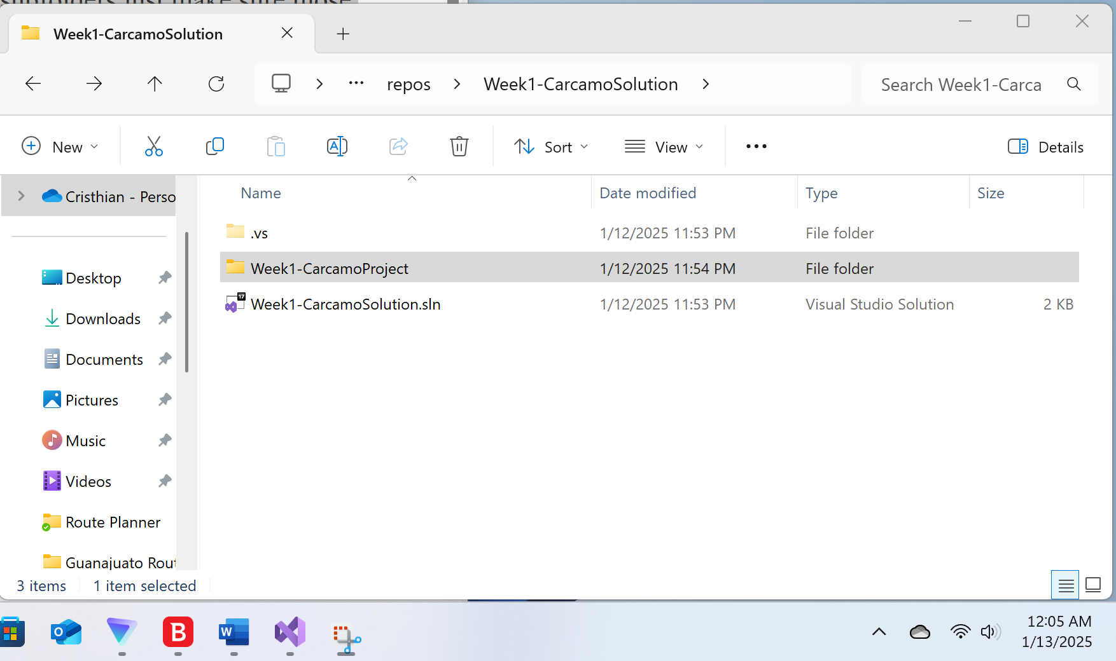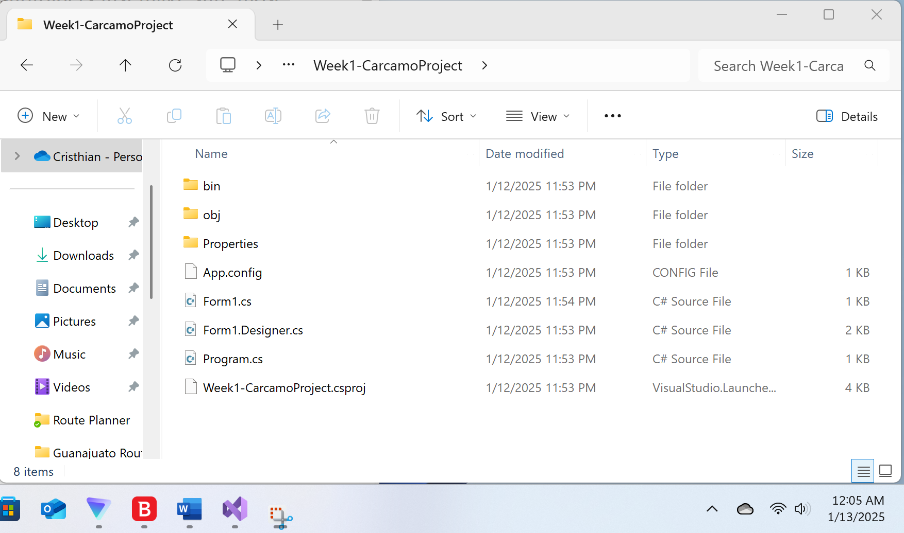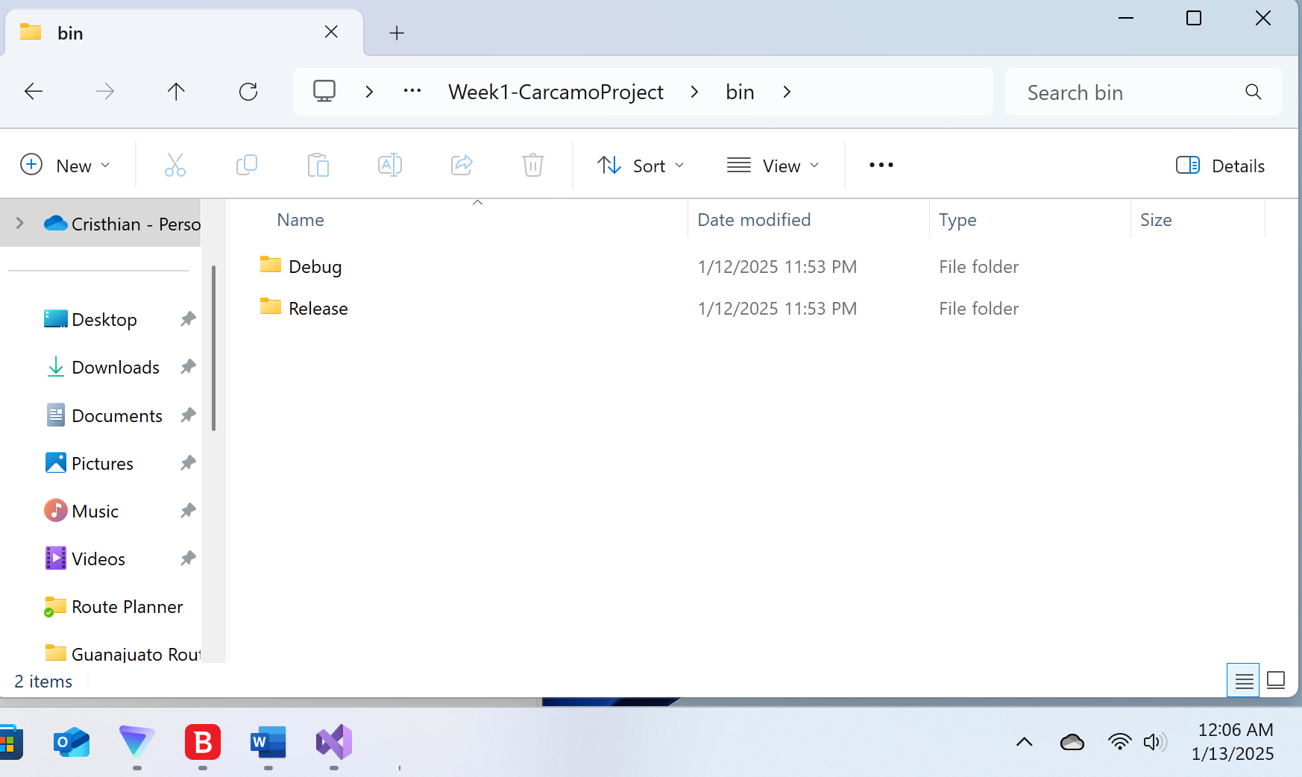

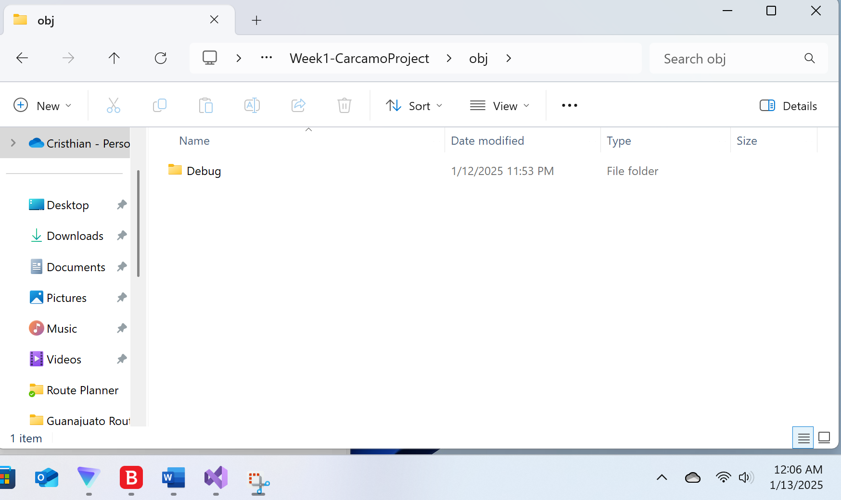

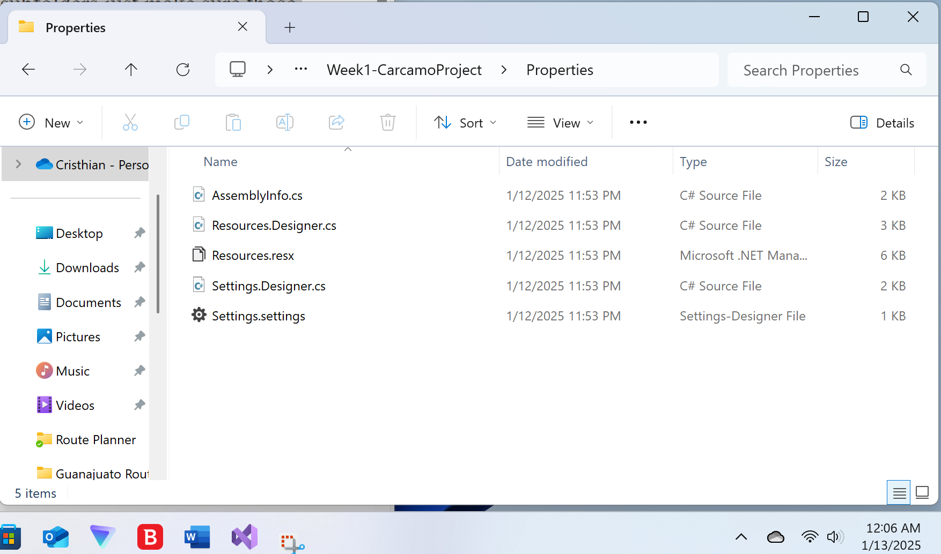

Now open up Visual Studio and load in your project. If the project opens to the code window, go to the form window then take the follow screen shots and label them appropriately.

* Show the Visual Studio with your project open, displaying the form but not the code
  + Label the Toolbox
  + Label the Form Designer Window
  + Label the Property Window
  + Label the Solution Explorer Window
* Show the Visual Studio with your project open but show the code window
  + The may not be any code but that is okay
  + Label the Code Editor Window
  + Label the Properties Window
  + Label the Solution Explore Window
* Show a Solution Explorer with the tree expanded out so you see the various files
  + Label which one is the Form designer File
  + Label which one is the Code File

